

**DIGITAL WELL-BEING MANGEMENT SYSTEM**

**A MINI-PROJECT REPORT**

***of***

**BACHELOR OF TECHNOLOGY**

***in***

**DEPARTMENT OF COMPUTER SCIENCE & ENGINEERING**

***at***

**DAYANANDA SAGAR UNIVERSITY**

**SCHOOL OF ENGINEERING, BANGALORE-560068**

**5TH SEMESTER**

**(Course Code: 16CS305)**

**OBJECT ORIENTED PROGRAMMING**

***Submitted By:***

**Shylesh S, ENG18CS0274**

**Shreyansh JV - ENG18CS0268**

**V A S Kiranmayee - ENG18CS0304**

**Srishti Ranjan - ENG18CS0284**

**DAYANANDA SAGAR UNIVERSITY**



**CERTIFICATE**

This is to certify that the Object Oriented Programming Mini-Project report entitled **“DIGITAL WELL-BEING MANGEMENT SYSTEM”** being submitted by V A S Kiranmayee – ENG18CS0304 to Department of Computer Science and Engineering, School of Engineering, Dayananda Sagar University, Bangalore, for the 5th semester B.Tech C.S.E of this university during the academic year

2020-2021.

***Date***:___________ ____________________________

***Signature of the Faculty in Charge***

____________________________

***Signature of the Chairman***

**DAYANANDA SAGAR UNIVERSITY**



**CERTIFICATE**

This is to certify that the Object Oriented Programming Mini-Project report entitled **“DIGITAL WELL-BEING MANGEMENT SYSTEM”** being submitted by Srishti Ranjan – ENG18CS0284 to Department of Computer Science and Engineering, School of Engineering, Dayananda Sagar University, Bangalore, for the 5th semester B.Tech C.S.E of this university during the academic year

2020-2021.

***Date***:___________ ____________________________

***Signature of the Faculty in Charge***

____________________________

***Signature of the Chairman***

**DAYANANDA SAGAR UNIVERSITY**



**CERTIFICATE**

This is to certify that the Object Oriented Programming Mini-Project report entitled **“DIGITAL WELL-BEING MANGEMENT SYSTEM”** being submitted by Shylesh Suresh - ENG18CS0274 to Department of Computer Science and Engineering, School of Engineering, Dayananda Sagar University, Bangalore, for the 5th semester B.Tech C.S.E of this university during the academic year

2020-2021.

***Date***:___________ ____________________________

***Signature of the Faculty in Charge***

____________________________

***Signature of the Chairman***

**DAYANANDA SAGAR UNIVERSITY**



**CERTIFICATE**

This is to certify that the Object Oriented Programming Mini-Project report entitled **“DIGITAL WELL-BEING MANGEMENT SYSTEM”** being submitted by Shreyansh J V – ENG18CS0268 to Department of Computer Science and Engineering, School of Engineering, Dayananda Sagar University, Bangalore, for the 5th semester B.Tech C.S.E of this university during the academic year

2020-2021.

***Date***:___________ ____________________________

***Signature of the Faculty in Charge***

____________________________

***Signature of the Chairman***

# **TABLE OF CONTENTS**

**Chapter No.** **TITLE**   **Page No**

1. Introduction
   1. Problem Statement
   2. Objectives of the project
2. Literature Survey
   1. Existing System
   2. Proposed Solution
3. System Requirements
   1. Functional Requirements
   2. Software and Hardware Requirements
4. System Design
   1. Architecture/Data Flow Diagrams
   2. Modules – Class Diagrams
5. Experimental Investigations
6. Results - Screen Shots
7. Conclusion
8. Future Scope

References

# 

1. **INTRODUCTION**

# The digital world is a rapidly growing part of our lives today, and young people are spending more and more time with digital devices. In particular, the rise of access to mobile digital devices and the internet also bring huge benefits on a global scale for improving access to and quality of education amongst children

Digital wellbeing is a term used by health professionals, researchers and device manufacturers to describe the concept that when humans interact with technology, the experience should support mental and/or physical health in a measurable way. The goal of improving digital wellbeing is to design technology in such a way that it promotes healthy use and proactively assists the user to maintain a healthy lifestyle.

This helps the user to lower undesired types of screen time, or to be more deliberate about how technology is used.

For the young people today, who grow up with access to digital devices from birth, the difference between online and offline environments are often not distinguishable when compared with adults who remember growing up without them.

* 1. **PROBLEM STATEMENT**

When optimizing digital health, multiple health-related components can be taken into consideration. This can include:

* Overuse of our phones and devices like laptop or tablet can result in a number of different physical problems that may cause permanent damage or be difficult to treat, including: Digital eye strain. The pain and discomfort associated with viewing a digital screen for over 2 hours. Eyes begin to burn and itch.
* Being aware of unforeseen mental health impacts. One example of an adverse feature to mental health is the endless scroll addition to [social media](https://whatis.techtarget.com/definition/social-media) platforms like [Facebook](https://whatis.techtarget.com/definition/Facebook) and [Instagram](https://searchcio.techtarget.com/definition/Instagram). This has been attributed to internet addiction which has been correlated with high levels of anxiety, ADHD, depression, poor time management and impulsiveness.
* Cell phones cause stress in many ways and in many forms. When one gets used to a cell phone, they also become slowly dependent on it. It becomes very difficult, then, to be apart from it for any period of time. We start fidgeting and worrying when our cell phones start losing battery. Moreover, new research shows how people get anxious when they can’t answer calls or reply to texts once they see their mobile phone’s screen light up, even if they are in a meeting, or a lecture.
* Continuously holding the cell phone in one position, constant use of fingers while sending e-mails ant text messages at rapid speed causes extreme pain and inflammation. We all have the habit of multitasking. Thus, holding the phone between the ear, neck and shoulder increases the risk of back pain. “Long periods of cell phone use cause you to arch your neck and hold your body in a strange posture.
* Recent studies show that, within five minutes of waking up, 90% of people check their phones. Exposing your eyes to that kind of light in the day itself is harmful, but right after you wake up, when you can’t even make out what is what, it is extremely harmful.

**1.2 OBJECTIVES OF THE PROJECT**

* Digital Wellbeing will help people build a more mindful and healthy relationship with technology, by giving them the tools necessary to be able to use technology to enhance the pursuit of their goals. By delving into daily habits and lifestyle, they not only look for quick wins, but look at the sustainability element of the relationship and dependency on tech, helping to develop new habits and improve quality of life.
* Our overall wellbeing is determined by the physical and emotional experiences we have on a daily basis. As technology continues to be such a huge part of our lives, from the way we represent who we are to the interactions we have with others, it too has an impact on our wellbeing. This is often referred to as your 'digital wellbeing' or 'online wellness.'
* So, our database helps us overcome these challenges by simply keeping a record of how much time we spend on the device, it provides us with a daily view of how often we check our phone and how frequently we use different apps and for how long. We are entitled to set limits with daily app timers, so once we set a limit, it reminds the user when the screen limit time has exceeded so that the user can stop using his device, and if the screen limit time is not exceeded, the user is free to continue using different applications on his device or the user can also choose to exit the application.

1. **LITERATURE SURVEY**
   1. **EXISTING SYSTEM**

There are quite a few existing systems on digital wellbeing. They mainly focus on the screen time, the number of unlocks, the average time spent on each app and so on. They usually are premade apps in either Google play store or they are inbuilt in our electronic devices. When it comes to food intake, we have a system called cult. Fit which helps keep track of what is being eaten and so on. In physical exercise field, there are smart watched that are developed by different companies which have sensors and keep track of the heart rate. These data is then sent to a cloud database which you can view from your mobile or other electronics.

* 1. **PROPOSED SOLUTION**

The end goal of a project is to deliver a high quality product exactly as the customer asked for. Functional requirements are the primary way that a customer communicates their requirements to the project team.

Functional requirements help to keep project team going in the right direction. Here in our project we have a few certain goals to achieve, the calculation of the average screen time, the time spent on individual app, time spent surfing on net and their particular sites.

1. **SYSTEM REQUIREMENTS**
   1. **FUNCTIONAL REQUIREMENTS**

The end goal of a project is to [deliver a high quality product](https://reqtest.com/testing-blog/guide-deliver-quality-product-satisfy-customers/) exactly as the customer asked for. Functional requirements are the primary way that a customer communicates their requirements to the project team. Functional requirements help to keep project team going in the right direction. Here in our project we have a few certain goals to achieve. The calculation of the average screen time, the time spent on individual app, time spent surfing on net and their particular sites and so on. The developed project would also keep track of the calories intake via food and notify us when we exceed certain calorie requirement. It also helps us keep track of out physical exercise.

* 1. **SOFTWARE AND HARDWARE REQUIREMENTS**

External interface requirements specify the hardware, software or database elements to which a system must interface. A small-scale database that is to be filled up by the user. The laptop or desktop shall be the computer that the application is being used upon. The min. of 500 MB RAM space required. As for software requirements, we would need the Net Beans software latest version (preferably 8.1) and MySQL workbench. Usually while making the connectivity the installed application may not have all the necessary files to connect to the MySQL server, under such circumstances we would need a java Connector .jar file. It is available for download on the internet in a zip format.

System Features

* Data Availability
* Minimized Redundancy.
* Data Accuracy, Consistency and Relevance.

Non-functional Requirements

## Performance Requirements

Here in our project we have a few certain goals to achieve. The calculation of the average screen time, the time spent on individual app, time spent surfing on net and their particular sites and so on.

## Safety Requirements

This application is solely developed to track and analyze the mobile usage of a person, it can help get rid of addiction is it shows you the average mobile usage per month or per day. It can also keep track of what apps are more frequently used and what are not. The developed project would also keep track of the calories intake via food and notify us when we exceed certain calorie requirement. It also helps us keep track of out physical exercise.

1. **SYSTEM DESIGN**
   1. **ARCHITECTURE/DATA FLOW DIAGRAMS**

The following diagram is a pictorial representation of the architecture of our project. When the user unlocks his device, he can choose to browse any application on his device, once the screen time is captured and if the user’s screen time has exceeded the given limit, then a warning will be generated asking the user to exit the application. If the screen limit has not been reached, then the user is free to browse through different applications or he can even choose to exit anytime before the screen limit is captured.

* 1. **MODULES – CLASS DIAGRAMS**

Class diagrams are the main building block in object-oriented modeling. They are used to show the different objects in a system, their attributes, their operations and the relationships among them.

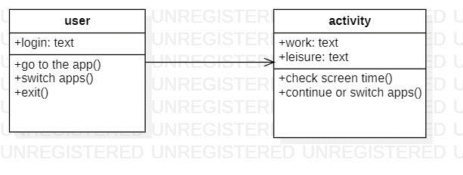

In our class diagram, we have two systems, user and activity. Our ‘user’ system has an object ‘login’ from where the user’s phone/computer can be accessed through a passcode. So, the system ‘user’ is allowed to perform operations like go to the application and browse, switch between different applications and exit once the user has finished working. And the user’s activity will be recorded through the relationship between the two systems. The activity system has two objects, ‘work’ and ‘leisure’ by which our user’s screen time will be calculated depending on the two operations from the activity system, ‘check screen time()’ and ‘continue or switch apps()’, where ‘check screen time()’ will check if the user has exceeded the time limit, and if the user has, then a warning will be generated requesting the user to exit the application. If the user has not exceeded the time limit, this will bring us to the second operation ‘continue or switch apps()’ which will allow the user to continue the usage of the application by either switching to another application or using the same application, the user is also allowed to exit all applications according to his/her choice.

1. **EXPERIMENTAL INVESTIGATIONS**

CASE 1: Exceeded threshold screen time limit

If the total time is less than 2 hours then it displays a message showing that “you can continue using this app, or you can switch to another app…”

CASE 2: Time is not exceeding the threshold time limit

If we have used the app for more than two hours it shows a message saying “You have used the app for more than 2 hours!!!”

CASE 3: If the total calorie intake is more than 2000 calories

If the food we ate contains more than the amount of calories pre-specified (in this case 2000 calories) then a message of warning will show up saying “The calories is more than 2000!!!”

1. **RESULTS - SCREEN SHOTS**

For the first part, let’s take electronics into consideration. We enter the electronics id which is nothing but the day and the month i.e. 1210 which is the 12th day of the 10th month. Then we enter what app we used, we choose it from the combo box. We enter the start time and the end time of the app usage. We enter it using military time. Then we hit the calculate button. It calculates the total screen time and then displays the result.

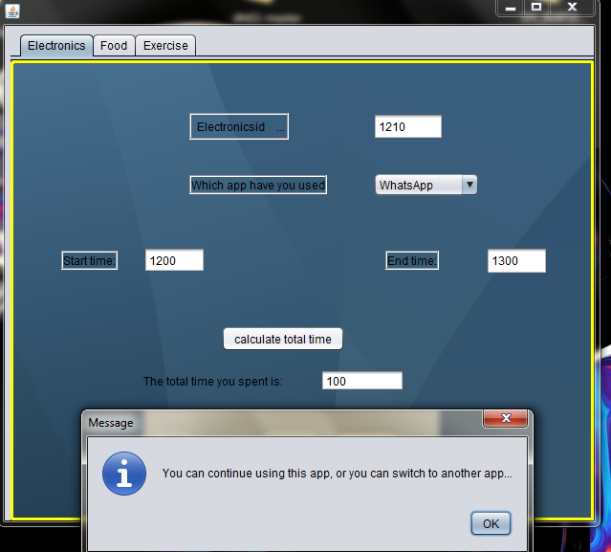

If the total time is less than 2 hours then it displays a message showing that “you can continue using this app, or you can switch to another app…” If we have used the app for more than two hours it shows a message saying “You have used the app for more than 2 hours!!!”

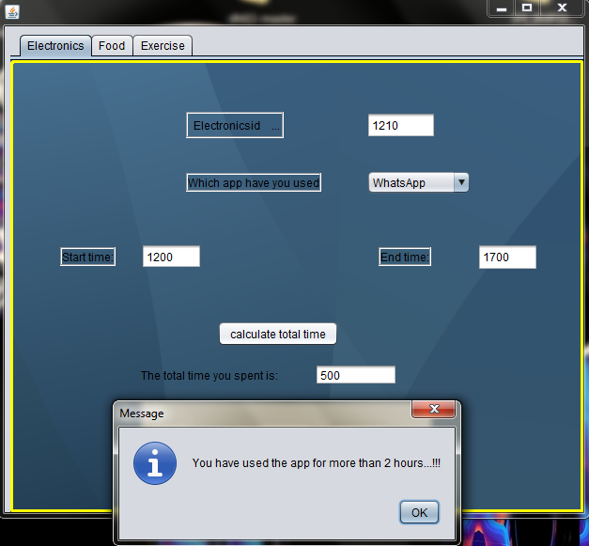

Similarly, on 29th day of 10th month, we have inserted the record again on what time we started using the application i.e, 1200 and the end time is 1700, and the time spent was on the ‘whatsapp’ application. So, we can add the records into the table to calculate the screen time and in the same way, we can simply delete the record too and it will show in the database.

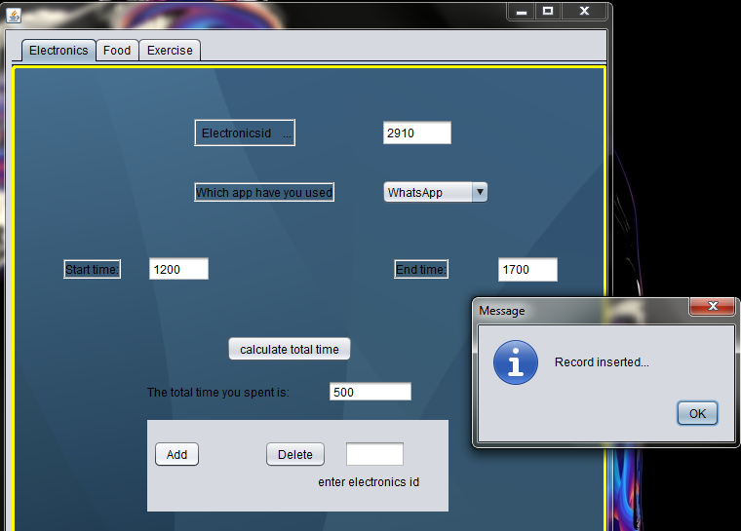

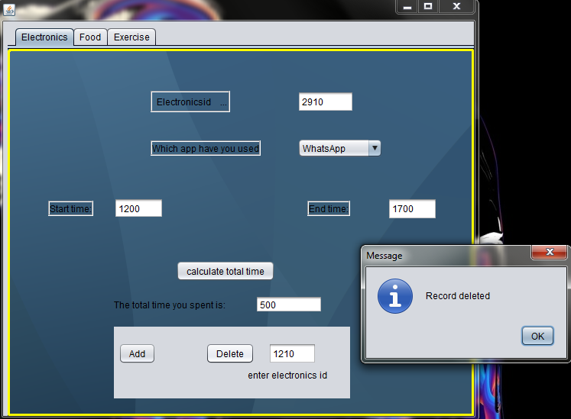

Similarly, when we go to the food section, we first begin with the foodid which is nothing but date and month i.e, 27th of 12th month. Next, we enter the food we ate and how many portions we ate. Then, it calculates the calories intake and sends out a message with the number of calories taken. This proves helpful as we can keep a count of what our intake is like and stay healthy. We can also perform insertion and deletion of the data into the table.

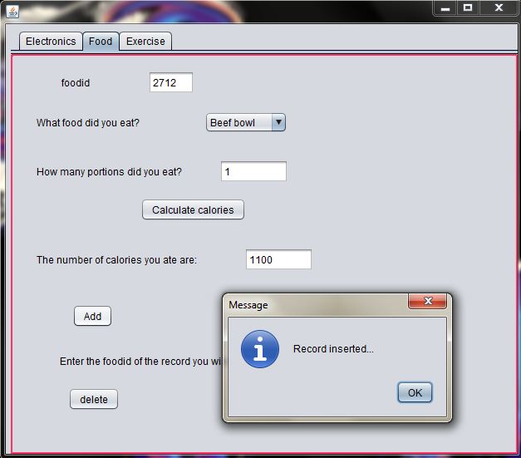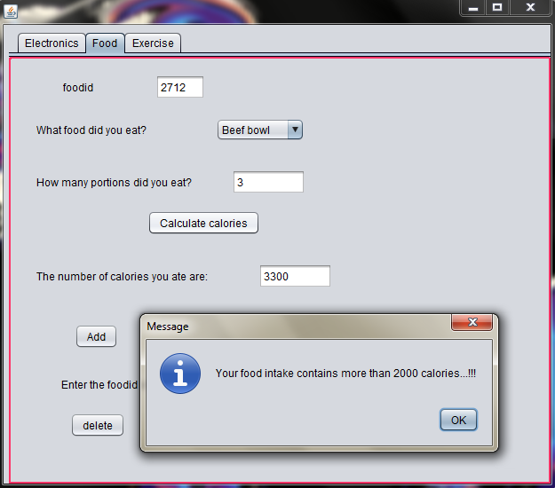

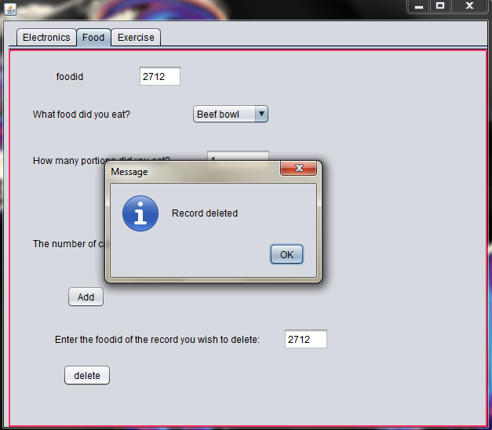

And in our last section, we have exercise option, where we need to enter the exerciseid which is the day and month. Then we have certain workout routines displayed in our description box, each routine has different set of exercises. The user is entitled to choose one routine per day. So the user will pick the routine and enter the details, then the user has to enter how many sets of the routine was performed. Ans, according to the entered details, the burnt calories will be shown as an output, ensuring us about the healthy lifestyle. AND, we can insert and delete details like we did previously.

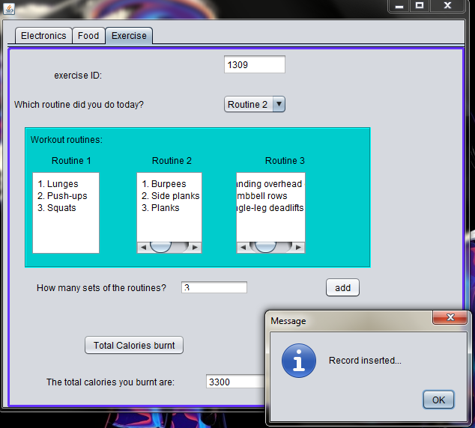

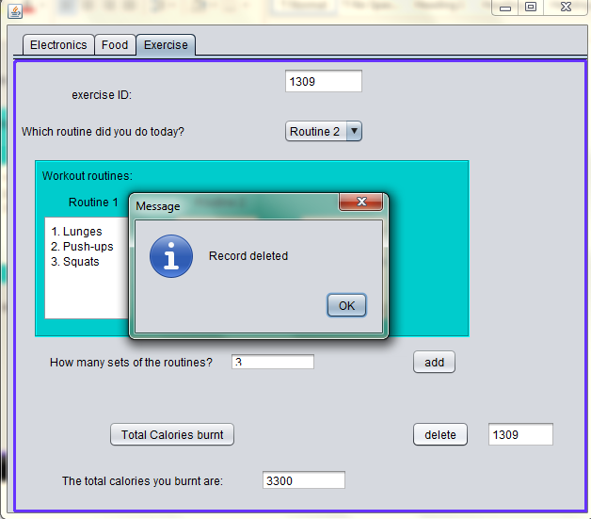

1. **CONCLUSION**

The purpose of this document is to define the requirements of our digital well-being management system. Our project emphasizes more on helping people from the addictive grasp of technology which has a major impact on their health. So, our project helps in Increasing emphasis on physical activity and nutrition. Many technological devices have been developed to help devices users bring up fitness levels, and monitor diet. Supporting healthy sleep patterns, especially for users that bring devices with them to bed. Users can set their devices to turn off certain features at bedtime or change the screen contrast or switch to grayscale to reduce eye strain. Overall, it helps in creating a healthy lifestyle with precisely adequate use of technology.

1. **FUTURE SCOPE**

The goals of digital wellbeing are complex and diverse.

* The goal of improving digital wellbeing is to design technology in such a way that it promotes healthy use and proactively assists the user to maintain a healthy lifestyle
* Prevention of diseases due to excessive screen time.
* **Help people live long and healthy lives**
* Assistance with monitoring the calories intake and water intake.
* **Looking after personal health, safety, relationships and work-life balance in digital settings.** Reducing eye strain in frequent device users.
* Enhances self-control, and self-improvement.
* Engaging in conversation that does not involve usage of our phone will lead to better social interaction and interpersonal skills, as well as helping you to maintain healthy relationships with family and friends.
* Limiting screen time to a certain number of minutes or hours over the course of a day or week.

1. **REFERENCES**
   1. <https://netbeans.org/kb/docs/ide/mysql.html>
   2. <https://www.geekinsta.com/how-to-connect-java-application-with-mysql-using-netbeans/>
   3. <https://www.javatpoint.com/example-to-connect-to-the-mysql-database>
   4. <https://netbeans.org/kb/docs/java/quickstart.html>
   5. <https://dev.mysql.com/doc/connector-j/8.0/en/connector-j-usagenotes-statements.html>